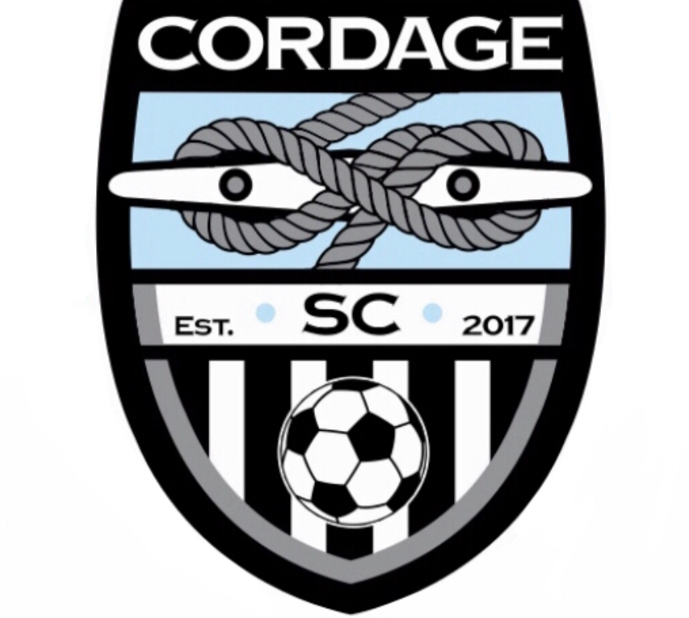

Cordage Soccer Club - Emergency Action Plan (EAP)
Updated February 2020
The following injuries constitute a medical emergency and require ​immediate medical attention:
- Blockage or stoppage of airway, breathing or circulation
- Loss of consciousness
- Any type of seizure
- Severe bleeding
- Severe fracture, dislocation or deformity
- Any injury to the head, neck or spine
- Heat illness: Change in facial color or appearance, extreme fatigue, disorientation, severe vomiting or loss of consciousness.
- Diabetic Emergencies
- Severe asthma or allergy attack
In the event of a medical emergency the following steps should be taken:
1​. If an ambulance is needed, call 911
2. Notify the nearest Cordage SC coach​​ that EMS has been activated.
3​. Call ahead to the emergency room the athlete is being sent to.
4​. Make sure you have the following information​​ on the athlete: Name, Date of Birth, injury, parents’ names and phone numbers.
ROLES IN EMERGENCY ACTION PLAN (EAP)
Role 1 (Director, Coach, Manager)
o Look after and care for athlete
o Assess athlete and decide if advanced medical help is needed.
o Make sure the athlete is not moved until they are sure no serious injury has occurred.
o Instructs coach, game manager or event personnel to activate EMS (911)
o Performs any first aid/CPR that is required
o Is appropriately trained for this position.

Role 2 (Director, Coach, Manager, Assistant)
o Control the crowd, including concerned parents of the athlete
o Recruit help to the scene if needed
o Aids in crowd control
o Make sure the EMS have a clear pathway to the injured athlete
o Meet EMS or send assistant coach to meet EMS
Role 3 (Director, Coach, Manager, Assistant)

o Accompany athlete in the ambulance if parents are not on site

Emergency Equipment onsite

o First Aid kits
o Ice packs
911 Emergency Phone Guidelines:

When dialing 911 please have the following information available to give the dispatcher:
1. Location of athlete including landmarks and/or road names. ​BE AS SPECIFIC AS POSSIBLE!
2. Location of where the ambulance will be met by designated person (to aid with directions).
3. Please designate a person to meet ambulance at entrance (depending on venue)
4. Caller’s name and phone number
5. As much information about athlete as possible:
Name, gender, age, current medical condition and mental status, medical history, allergies to medications

- Example Script: ​ “My name is ____________ and I have an athlete in need of immediate medical attention at ______________. The athlete is a 16-year-old male suffering from ________. Please meet ____________ at the main entrance to the facility and he will help direct the ambulance to us.”
Cordage Soccer Club will refer to the U.S. Soccer Federation’s “Recognize to Recover” guidelines for the following: Brain Injury/Concussion, Cardiac Emergency, Weather (Extreme Heat and Cold temperatures)

RECOGNIZE: Brain Injury/Concussion

Changes in brain functions:
- Unaware of game (opposition colors, score of game, last play)
- Confusion
- Amnesia (does not recall events prior to the hit or after the hit)
- Drastic changes in alertness
- Does not know time, place or date
- Slowed responses to questions or conversation
- Decreased attention and concentration
Mental and emotional changes:
- Depression
- Anxiety
- Anger
- Irritability
- Emotionally unstable
Physical changes:
- Headache
- Dizziness
- Nausea
- Unsteadiness/loss of balance
- Feeling “dinged” or stunned or “dazed”
- Seeing stars or flashing lights
- Ringing in the ears
- Double vision

RECOVER

Remove, Evaluate and Rest are key steps to treating a concussion or other head injury in soccer. When a concussion is identified quickly, it prevents the injury from getting worse, and prevents the player from staying off the field for even longer.
REMOVE
An athlete who experiences a blow to the head or body should immediately be removed for play and should not return to play until he/she is evaluated. When in doubt, the athlete should sit out.
EVALUATE
Have a health care professional evaluate the athlete immediately. Do not try to judge the severity of the injury yourself.
REST
Never rush a return to play. A return to play should only occur after an athlete has been cleared by a medical professional. If you rush the return, a player is at significantly higher risk for more problems in the future.

RECOGNIZE: Cardiac Emergency
- Warning symptoms of an existing heart condition include: chest pain and/or passing out with exercise; racing heart; and/or a family member who died suddenly from a heart condition or suffered sudden cardiac arrest before the age of 50.
- The first sign of cardiac arrest is when a player collapses without contact during practice or a game.
- Risk factors for sudden cardiac arrest include: smoking, obesity, diabetes, sedentary lifestyle and drug abuse.
- Males and African - Americans are more likely to suffer from sudden cardiac arrest.

RECOVER
- Have a plan identifying quick help for all practices and games.
- Identify the collapsed individual.
- Assign someone to call 911, and someone to retrieve an automated external defibrillator (AED).
- Start hands-only CPR – chest compressions in the center of the chest, pushing hard and fast. Hands-only CPR is easier to remember, perform, and teach than traditional CPR. It also does not require mouth-to-mouth contact.
- Continue chest compressions. Once the AED arrives, place the pads on the individual as shown by the device. The AED will guide you by voice on next steps.
- If no AED is available, continue chest compressions until emergency personnel arrive. Switch with another person if you get tired.
- Coaches, parents, players and referees that have CPR training and access to an automated external defibrillator (AED) can save lives. In fact, when an AED is used within three minutes of a collapse, there is an 89 percent survival rate.

RECOGNIZE: Extreme Heat
Thirst is a warning that your body is already in an early stage of dehydration. Drink when you are thirsty. Recognizing the signs of dehydration are important because the amount of water required will vary from player to player.
- Dry, sticky mouth
- Sleepiness or tiredness
- Headache
- Dizziness or lightheadedness
- Rapid heartbeat
- Rapid breathing
- Fever
- In the most serious cases, delirium or unconsciousness

RECOVER
- Add hydration breaks
- Shorten practice
- Practice early or late in the day when temperatures are lower
- Use less-strenuous training activities during practice

RECOGNIZE: Frostbite
- Swelling/Edema
- Redness or mottled gray skin appearance
- Tingling or burning
- Blisters
- Numbness or loss of sensation

RECOVER
- Gradually rewarm affected area with warm water

WARNING:
- Do not rub or massage the frostbitten area. This may actually increase the damage.
- Do not use heating pads, heat lamps or the heat of a stove, fireplace, or radiator for warming since affected areas are numb and can be easily burned
*If any of the symptoms persist for longer than a few hours, seek medical attention from emergency department or physician.

RECOGNIZE: Hypothermia
- Shivering vigorously or suddenly not shivering
- Increased blood pressure
- Lethargy
- Impaired mental function
- Slurred speech

RECOVER
- Remove damp/wet clothing
- Apply heat to the trunk of the body, not limbs
- Provide warm fluids and food
- Avoid applying friction massage to tissues

WARNING:
Do not use a hot shower or bath to treat hypothermia because it could cause the individual to go into shock.
*If symptoms persist seek medical attention from a physician or Emergency department.
LIGHTNING POLICY AND PLAN (Recommended Plan)
When there is visual sighting of lightning OR audible sound of thunder:
  - DIRECTOR / ADMIN or COACH will clear all fields. All coaches, athletes and/or spectators must move INSIDE to a secured covered area or INSIDE their personal vehicles.
  - All outdoor activity will be suspended for 30 minutes from the last lightning strike or sound of thunder.
• All outdoor activity may also be suspended at the discretion of the DIRECTOR / ADMIN or COACH if lightning is detected within ​eight (8) miles​​ of any and all parks.
  - DIRECTOR / ADMIN or COACH may reopen fields after 30 minutes have elapsed without visible lightning or audible thunder.

